**Formulation of** **Risperidone Nano Niosomal Vesicular System by Ecofriendly Direct Ultrasonication Method**

**Mohamed I.](mailto:drfatimajalal@copharm.uobaghdad.edu.iq)

1Ministry of Health, Baghdad Al-Rusafa Health Directorate, Pharmacy Department, Baghdad, Iraq.

2 Department of Pharmaceutics, College of Pharmacy, University of Baghdad, Baghdad, Iraq.

**\*Corresponding Author**

Received 19/5/2024, Accepted 23/10/2024, Published 25/6/2025

[Creative Commons License](http://creativecommons.org/licenses/by/4.0/) This work is licensed under a Creative Commons Attribution 4.0 International License.

**Abstract**

Risperidone is atypical antipsychotic agent used mainly in treating schizophrenia; it is classified as class II in BCS classification. Nanovesicular system may provide a circumvent to these hurdles. This study aims to enhance the delivery of risperidone using nanovesicular system while minimizing environmental impact, potentially increasing therapeutic efficacy. The preparation method was ecofriendly direct sonication. Span 60, cholesterol, and drug at a fixed amounts were added to different concentrations of dicetyl phosphate ((0,3,6,12,18, and 24mg)/10 mL) to give six formulations. The final mixtures were added to phosphate buffer saline pH 7.4 and sonicated at 60 °C without usage of organic solvents along the process of formulation. Dynamic light scattering, zeta potential, entrapment efficiency percentage, transmission electron microscopy (TEM), and *in vitro* release were used to assess the characteristics of the formulations. Fourier transform infrared (FTIR) spectra were implemented to investigate possibility of drug-excipients interactions. The particle size range was (193.97±1.85 - 427.23±199.27 nm), particle size distribution (PDI) (0.13±0.06 - 0.62±0.10), TEM showed a vesicular shape of the prepared formula, and entrapment efficiency percentage (48.07±0.20 - 87.40±0.33%). Formula containing dicetyl phosphate at concentration (18mg/10 ml) showed the lowest mean particle size (193.97 nm), lowest mean of PDI (0.13), lowest zeta potential mean (-20.10mV), and entrapment efficiency percentage mean of 50.9%. Furthermore, the release was 68.17% of drug after 12 hours, and the FTIR spectra reveal no interaction between drug and excipients in the formula. Most physical characteristics of risperidone nanovesicles were improved by adding dicetyl phosphate, compared with formulation without dicetyl phosphate. A stable nanovesicular system can be achieved by utilizing direct ultrasonication method and addition of charge inducing agent (dicetyl phosphate) without the need of using organic solvent.

**Keywords: Dicetyl Phosphate, Nanovesicular, Risperidone, Span 60, Ultrasonication.**

**Introduction**

Nanovesicular system was used as a novel drug delivery system for both hydrophilic and hydrophilic drugs; nonionic vesicles without phospholipids (noisomes) are more economic in expenses; niosomes contain cholesterol instead of phospholipids, which are used in formulation of liposomes and other lipid vesicles such as ethosomes (1,2).Niosomes consist of non-ionic surfactants, which exhibit greater chemical stability than the phospholipids utilized in liposomes. This stability mitigates the risk of oxidation and degradation, prevalent concerns in liposomal systems. Furthermore, cholesterol provides rigidity to the membrane of the vesicles. Consequently, the niosomes exhibit physical stability higher than other lipid containing vesicles (3).

In addition, niosomes were used to improve bioavailability, as Abou‐Taleb et al. found that niosomal vesicles containing nefopam hydrochloride, an analgesic drug, can be effectively used for nasal drug delivery to improve bioavailability, and a significant increase in bioavailability by nearly 4.77-fold compared to the oral solution of the drug was achieved (4).

Ultrasonic direct method was used for vesicular formulations preparation for decades earlier, but it gets more attention recently due to its advantages of time saving and organic solvent free processes. Charge inducing agents are added to these vesicles to increase their physical stability (5,6).

Risperidone, classified as a second-generation atypical antipsychotic, exhibits a reduced incidence of systemic adverse effects

compared to first-generation typical antipsychotics (7). Many novel formulations were developed for risperidone delivery for many administration routes, such as oral, intravenous, intramuscular, and transdermal, as nano and nanovesicular systems, such as spanlastics, nanoemulsions, and solid lipid nanoparticles, have been investigated for their potential in delivering risperidone effectively to the brain (8,9,10).

Abdelrahman et al. conducted a study to investigate the suitability of a spanlastics nanovesicle for risperidone intranasal delivery. The spanlastics were made from Span® 60, a cosolvent (ethanol), and polyvinyl alcohol (PVA). The prepared system had a mean particle size of 103.4 nm, a poly dispersity index (PDI) of 0.341, and a zeta potential of −45.92 mV, indicating physical stability and minimal aggregation. The in vivo study reveals higher brain targeting for spanlastics than drug solution for intranasal delivery, suggesting the superiority of the developed nanosystem and high drug partitioning. The formulation was also found to be safe for intranasal administration, showing high biocompatibility in a histopathological study (sheep nasal mucosa) (11).

Abdallah et al. aimed to highlight the potentiality of intranasal ethanol/glycerin-containing lipid-nanovesicles (glycethosomes) incorporated into in situ gels for risperidone delivery (12). Đorđević et al. designed two risperidone nanoemulsions for parenteral administration. These nanoemulsions showed a lower elimination rate constant and a longer half-life time than other administered forms. Intranasal administration led to a lower plasma drug concentration, minimizing extravascular drug distribution and potential systemic side effects, making it a safer option than other routes of administration (13).

Though the previous studies mentioned above, there is a growing demand for developing efficient drug delivery for risperidone with environmentally friendly formulation method that can enhance the bioavailability and efficacy of risperidone while reducing the use of harmful solvents and minimizing waste production in pharmaceutical manufacturing (14,15).

**Materials and Methods**

***Materials***

Risperidone was obtained from Meryer Shanghai Biochemical Technology limited, China. Cholesterol was obtained from Hangzhou Dingyan Chem Limited, China. span 60 was provided by Sisco Research Laboratory Pvt. Ltd., India. Dicetyl phosphate (DCP) was purchased from Shanghai Macklin Biochemical Technology Co., Ltd., China. Other agents and solvents were of analytical grade or HPLC grade.

***Methods***

***Preparation of risperidone nanovesicles***

The preparation of nanovesicles was done by modified direct ultrasonication method, in which the intended amount of drug was added to a constant amount of span 60 and cholesterol, and then DCP was also added in different amounts (0,3,6,12,18, and 24mg). The final mixtures were added to 10 ml of phosphate buffer saline (PBS) pH 7.4 to prepare six formulations (ND0-ND5) (16,17), as illustrated in Table 1.

**Table 1. The Composition of Formulae**

|  |  |  |  |  |  |  |
| --- | --- | --- | --- | --- | --- | --- |
| **Materials** | **ND0** | **ND1** | **ND2** | **ND3** | **ND4** | **ND5** |
| Span 60 (mg) | 50 | 50 | 50 | 50 | 50 | 50 |
| Cholesterol (mg) | 45 | 45 | 45 | 45 | 45 | 45 |
| Risperidone (mg) | 24 | 24 | 24 | 24 | 24 | 24 |
| Dicetyl phosphate (mg) | 0 | 3 | 6 | 12 | 18 | 24 |
| PBS pH 7.4 (mL) | 10 | 10 | 10 | 10 | 10 | 10 |

The aqueous mixture was ultrasonicated by probe ultrasonicator (Q SONICA 500WATT 20kHz, USA) for two minutes at 30% amplitude (50 seconds on and 10 seconds off), then formula undergoes a sonication in a sonication bath at 63 °C for 15 minutes, followed by another two minutes of probe ultrasonication as described earlier (18).

***Dynamic light scattering and zeta potential measurement***

For dynamic light scattering (DLS), the sample was diluted appropriately to detect the vesicle size and particle size distribution index (PDI). The sample was measured by backscatter position; the angle of measurement was 183. The same procedure was repeated for zeta potential to detect electrophoretic mobility. The measures are represented as triplicate ±SD for vesicle size, PDI, and zeta potential. The measurement for DLS and zeta potential are done by Malvern zetasizer (19,20).

***Transmission electron microscopy***

By using transmission electron microscopy (TEM), the morphological features of the vesicular system for specific formulas were analyzed. A small amount of formulation was mixed with 1% of phosphotungstic acid. One drop of this mixture was placed on a carbon coated grid, and the excess sample was drawn out using filter paper. The sample was subsequently dried, and following the drying, the TEM analysis was conducted (21,22).

***Entrapment efficiency***

Entrapment efficiency is a measure for the amount of drug encaged in nanosystem. Ideally, high entrapment efficiency indicates there is no or little loss of drug during preparation process. Thus, high stability and targeting will be achieved with increasing entrapment efficiency (23,24).

Ultrafiltration method was used to separate free drug from formula by Amicon® 10000 Da., in centrifuge at 4000 rpm for 30 minutes at room temperature, then specified amount of filtrate was diluted in 10 ml of PBS pH 7.4 and spectroscopically measured by UV (Shimadzu, UV1900i) at 277 nm (25).

The entrapped amount is calculated by subtracting the free amount from the total amount of the drug in the formula. The entrapment efficiency as percentage (EE%) was calculated according to equation (1). Measures were done as triplicates and listed as mean ± SD.

$EE\%=\frac{Total drug in formula-Free drug }{Total drug in formula}×100\%$ (1)

***Release study***

Release study was executed by dialysis method. The dialysis membrane (8000-14000 molecular weight cutoff) was 24 hours soaked and washed in distilled water before the test. The dialysis membrane was sealed from one side, and a volume of 1 ml of formula was poured inside a dialysis membrane. The membrane was then clamped and immersed in a beaker containing 50 ml of 0.5% sodium dodecyl sulphate (PBS pH 7.4) over a magnetic stirrer at 50 rpm stirring speed and 37°C to assure sink condition (26).

The test was performed in triplicate for each formula. Samples were withdrawn from the release medium at scheduled time intervals (5, 10, 15, 30, 45, 60, 90, 120, 180, 240, 360, 540, 720 min) and the release medium was continuously replenished with fresh medium to maintain a fixed volume of 50 ml.

Finally, the samples were analyzed on the UV-VIS spectrophotometer at 277 nm wavelength (27).

***Fourier transform infrared spectroscopy***

The FTIR spectra were utilized on powder specimens (2-3 mg) that were mixed and compressed with KBr, corresponding to the samples of SPAN 60, cholesterol, risperidone, and physical mixture.

The FTIR analysis was conducted using ATR-FTIR on a liquid sample of the optimal formula, eliminating the need for KBr pretreatment (28,29,30).

***Statistical analysis***

One-way ANOVA and Tukey's tests were used to analyze multiple groups of data triplicates using GraphPad Prism 8.1, and DD solver addon was used for *in vitro* release data analysis using the similarity factor (f2), which is a logarithmic reciprocal square root transformation of the sum of squared error as an assessment of the similarity in the percentage (%) dissolution between the two curves. The dissolution profiles were considered similar when f2 was in the range of 50 to 100 (31).

**Results and Discussion**

From dynamic light scattering, particle size of vesicles was from 193.97±1.85 nm to 427.23±199.27 nm. As in Table-2, it was noted that the vesicle size decreases insignificantly (p>0.05) when the DCP concentration increases till reaching 18 mg/10 mL (ND4) at that concentration the decrease is significant (p<0.05) when compared with ND0 (formula without DCP). Additional increase of the DCP concentration to 24 mg/10 ml (ND5) did not result in further particle size decrease (Table2) (32).

**Table 2. The Characteristics of Vesicular Formulae n=3±SD**

|  |  |  |  |  |
| --- | --- | --- | --- | --- |
| **Formula code** | **Size (nm)** | **PDI** | **Zeta potential (mV)** | **Entrapment efficiency (%)** |
| ND0 | 427.23±199.27 | 0.57±0.19 | -14.24±4.59 | 87.40±0.33 |
| ND1 | 403.10±34.87 | 0.62±0.10 | -15.75±5.80 | 76.97±0.50 |
| ND2 | 245.87±39.55 | 0.28±0.08 | -11.38±2.88 | 68.02±1.39 |
| ND3 | 219.23±6.43 | 0.26±0.01 | -12.88±8.57 | 63.66±0.05 |
| ND4 | 193.97±1.85 | 0.13±0.06 | -20.10±2.17 | 50.90±0.50 |
| ND5 | 221.10±25.60 | 0.15±0.02 | -15.52±6.10 | 48.07±0.20 |

PDI was not directly decreased as DCP concentration increased (as shown above for particle size), though when reaching ND4 PDI is the lowest with significance of p<0.01when compared with ND0 (formula without DCP). Moreover, Zeta potential was lowest (p>0.05) as the DCP concentration reached 18 mg/10 mL (ND4), which is related to the physical stability of nanovesicular system; this may be due to the negative charge induced by DCP (Table 2) (32).

TEM micrograph (Figure.1) gives an obvious spherical vesicular shape in nano size range (29,33,34).

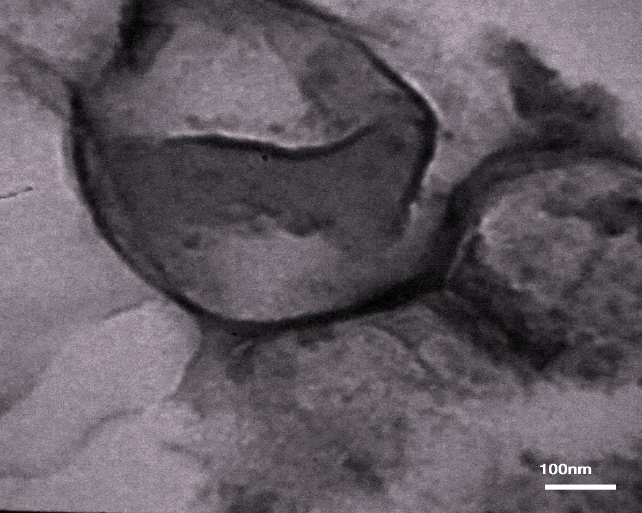

**Figure 1.** **Transmission electron microscopy (TEM) micrograph of ND4.**

Entrapment efficiency was decreased significantly as the DCP concentration increased (p<0.0001 for all formulations containing DCP), maybe due to a decrease of nanovesicular system size and/or the increase in the overall concentration of surfactants, which makes the drug more soluble in aqueous media, as in Table 2 (7,35).

DCP's negative charge caused smaller vesicles, which led to a decrease in entrapment efficiency. The vesicles are forced to be more curved and smaller in size due to repulsive forces caused by the charge on the surface of the bilayer. The smaller the size, the less volume enclosed in the core, and the fewer drugs entrapped (36).

FTIR of span 60 showed characteristic bands at 2916 (broad), 2846, and 1741 cm-1, as (-OH stretch), (-OH stretch), and 5-membered cyclic ring, respectively (18,37), indicating that the span 60 used is pure. Cholesterol spectrum had bands at 3408 (broad band), 2931 (broad band), and 1465 cm-1 as H- bonded alcohol, hydrocarbon band, and hydrocarbon band, respectively (37,38), which confirming the purity of cholesterol used. Risperidone showed the following bands at 1649, 1539, 1130, and 956 cm-1 as C=O stretching of aromatic ketone, C=C stretching of arene ring, C=F stretching of the aryl fluoride, and C-H aromatic bending, respectively, in risperidone spectrum, physical mixture of risperidone, span 60, cholesterol, and DCP (1:1:1:1) spectrum, and ND4 spectrum, which gave an evident of purity of risperidone used and no chemical interaction occurred between the drug and excipients in the formula (39,40,41,42), as shown in Figures. (2,3,4,5, and 6).

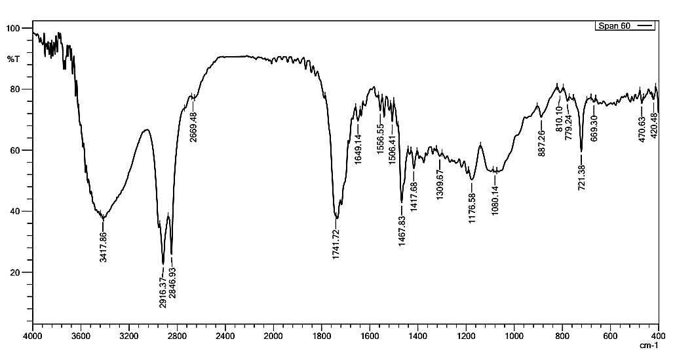

**Figure 2.** **FTIR spectrum of span 60.**

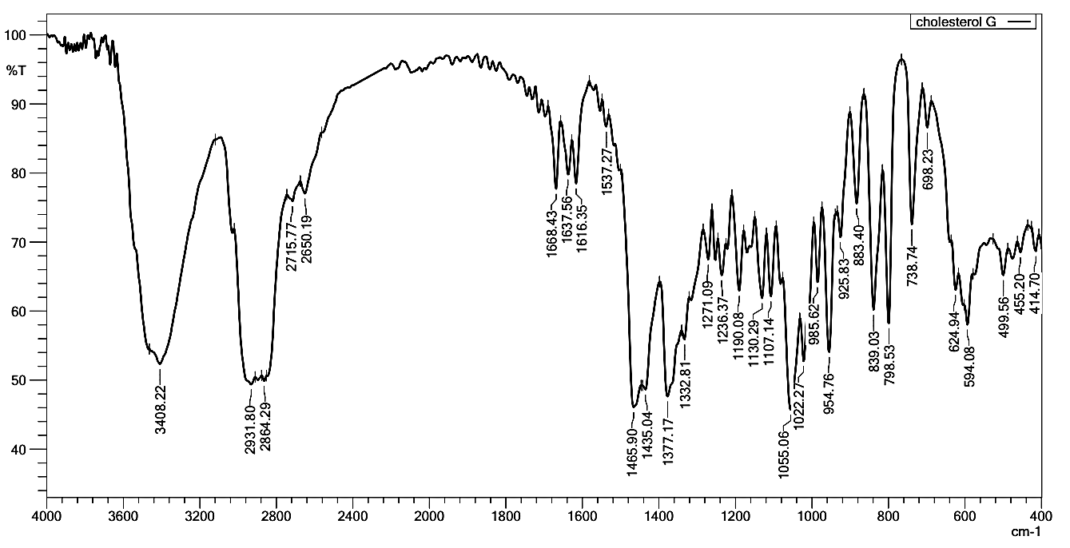

**Figure 3.** **FTIR spectrum of cholesterol.**

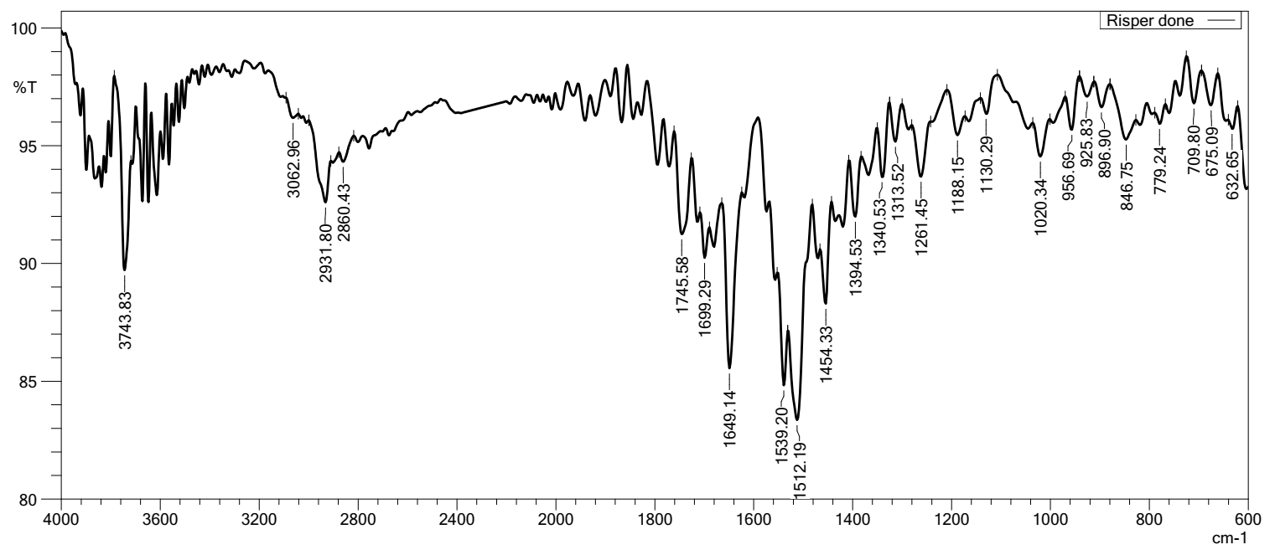

**Figure 4.** **FTIR spectrum of risperidone.**

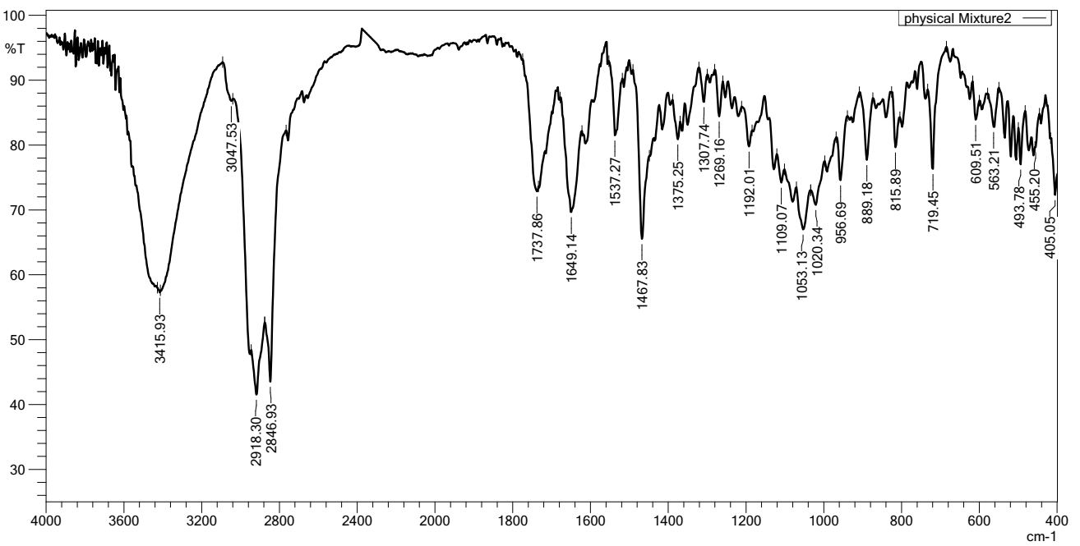

**Figure 5. FTIR spectrum of physical mixture.**

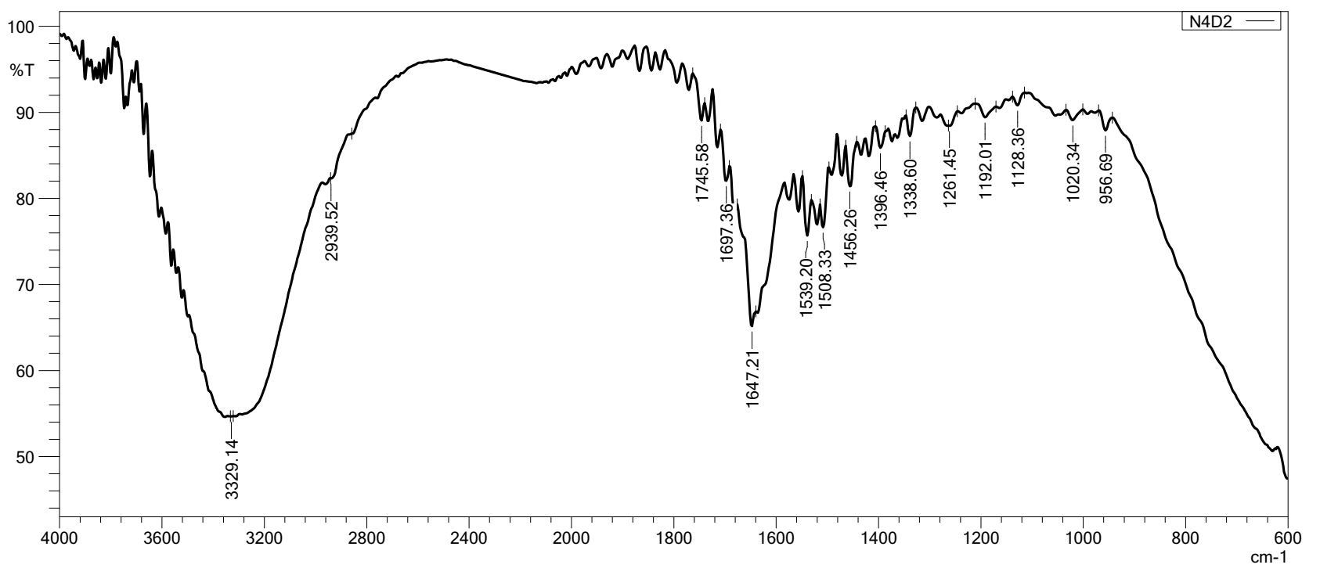

**Figure 6. ATR FTIR spectrum of ND4.**

The effect of addition of DCP on *in vitro* release can be seen obvious when compare the formulae ND0 (no DCP added and represent the formula with the largest size) and ND4, which is the formula of the smallest size (DCP 18 mg/10 ml) and ND5 (the highest concentration of the DCP in this study). Release rate comparison (by similarity factor F2 calculated with DDsolver addon) reveals a good similarity between ND4 and ND5 (F2=73.43), a difference between ND0 and ND4 (F2=43.12), and a difference between ND0 and ND5 (F2=39.04). Accumulative release was 60.5%, 68.17%, and 71.33% of drug after 12 hours for ND0, ND4, and ND5, respectively (31), as shown in Figure.7.

**Figure 7. Release profiles of ND0 (no DCP added), ND4(1.8 mg/ml of DCP), and ND5 (2.4 mg/ml of DCP) in PBS pH 7.4.**

**Conclusion**

Nano vesicular system of risperidone can be prepared by ecofriendly direct sonication method, the addition of charge inducing agent is necessary to decrease vesicle size and maintain stability, however unfortunately the entrapment decreased with decreasing vesicle size.

Further work for increasing entrapment is advised such as optimization of process variable and/or formula variables or adding excipient that may increase rigidity and stability of vesicular structure.

**Acknowledgment**

Authors acknowledge college of pharmacy university of Baghdad and the department of pharmaceutics for the support.

**Conflicts of Interest**

The authors declare there is no conflict of interest regarding the publication of manuscript.

**Funding**

The authors declare that the research received no financial support from any Institution.

**Ethics Statements**

The authors declare that the study needs no ethical approval from an ethics committee according to the research integrity rules in our country due to that the tests were *in vitro*.

**Author Contribution**

The authors confirm their contribution to the paper as follows: study conception and design: Fatima J. Al_Gawhari. Experimental work, results interpretation and statistical analysis, draft manuscript preparation: Mohamed I. Al- Shadedi. Both of authors reviewed the results and approved the final version of the manuscript.

**References**

1. Thabet Y, Elsabahy M, Eissa NG. Methods for preparation of niosomes: A focus on thin-film hydration method. Methods. 2022 Mar 1;199:9–15.
2. Kaur D, Kumar S. Niosomes: present scenario and future aspects. J Drug Deliv Ther. 2018;8(5):35–43.
3. Mandal S, Banerjee C, Ghosh S, Kuchlyan J, Sarkar N. Modulation of the photophysical properties of curcumin in nonionic surfactant (Tween-20) forming micelles and niosomes: A comparative study of different microenvironments. J Phys Chem B. 2013 Jun 13;117(23):6957–68. [doi:10.1021/jp403724g](https://pubs.acs.org/doi/abs/10.1021/jp403724g)
4. Heba A Abou-Taleb RAK, Abdel-Aleem JA. Intranasal niosomes of nefopam with improved bioavailability: preparation, optimization, and in-vivo evaluation. Drug Des Devel Ther. 2018;12:3501–16. [doi:10.2147/DDDT.S177746](https://doi.org/10.2147/DDDT.S177746)
5. Baillie Aj, Florence At, Hume Lr, Muirhead Gt, Rogerson A. The preparation and properties of niosomes—non-ionic surfactant vesicles. J Pharm Pharmacol. 1985 Dec 1;37(12):863–8.
6. Carafa M, Santucci E, Alhaique F, Coviello T, Murtas E, Riccieri FM, et al. Preparation and properties of new unilamellar non-ionic/ionic surfactant vesicles. Int J Pharm. 1998 Jan 12;160:51–9.
7. Jabar HE, Abd-Alhammid SN. Improvement of the Solubility and Dissolution Characteristics of Risperidone via Nanosuspension Formulations. Iraqi J Pharm Sci. 2022 Jun 9 ;31(1):43–56.
8. Correll CU, Kim E, Sliwa JK, Hamm W, Gopal S, Mathews M, et al. Pharmacokinetic characteristics of long-acting injectable antipsychotics for schizophrenia: an overview. CNS Drugs. 2021 Jan 1; 35(1):39–59. [doi:10.1007/s40263-020-00779-5](https://doi.org/10.1007/s40263-020-00779-5)
9. Froelich A, Osmałek T, Jadach B, Puri V, Michniak-Kohn B. Microemulsion-based media in nose-to-brain drug delivery. Pharmaceutics. 2021;13(2):1–37.
10. Stewart SA, Domínguez-Robles J, McIlorum VJ, Mancuso E, Lamprou DA, Donnelly RF, et al. Development of a biodegradable subcutaneous implant for prolonged drug delivery using 3D printing. Pharmaceutics. 2020 Feb 1;12(2).
11. Fatma Elzahraa A, Ibrahim E, Mary Kamal G, Ahmed Hassen E, Magdi Ibrahim M. Response surface optimization, *Ex vivo* and *In vivo* investigation of nasal spanlastics for bioavailability enhancement and brain targeting of risperidone. Int J Pharm. 2017 Sep 15; 530:1–11.
12. Abdallah MH, El-Horany HES, El-Nahas HM, Ibrahim TM. Tailoring risperidone-loaded glycethosomal in situ gels using box–behnken design for treatment of schizophrenia-induced rats via intranasal route. Pharmaceutics. 2023 Nov 1;15(11):2521.
13. Đorđević SM, Santrač A, Cekić ND, Marković BD, Divović B, Ilić TM, et al. Parenteral nanoemulsions of risperidone for enhanced brain delivery in acute psychosis: Physicochemical and in vivo performances. Int J Pharm. 2017 Nov 30;533(2):421–30.
14. Imam SS, Aqil M, Akhtar M, Sultana Y, Ali A. Formulation by design-based proniosome for accentuated transdermal delivery of risperidone: *in vitro* characterization and *in vivo* pharmacokinetic study. Drug Deliv. 2015;22(8):1059–70.
15. Tchobaniouk L V., McAllister EE, Bishop DL, Carpentier RM, Heins KR, Haight RJ, et al. Once-monthly subcutaneously administered risperidone in the treatment of schizophrenia: Patient considerations. Patient Prefer. Adherence. 2019;13:2233–41.
16. Mavaddati MA, Moztarzadeh F, Baghbani F. Effect of formulation and processing variables on dexamethasone entrapment and release of niosomes. J Clust Sci. 2015 Nov 1;26(6):2065–78.
17. Khan MM, Madni A, Tahir N, Parveen F, Khan S, Jan N, et al. Co-delivery of curcumin and cisplatin to enhance cytotoxicity of cisplatin using lipid-chitosan hybrid nanoparticles. Int J Nanomedicine. 2020;15:2207–17.
18. Khan MI, Madni A, Hirvonen J, Peltonen L. Ultrasonic processing technique as a green preparation approach for diacerein-loaded niosomes. AAPS PharmSciTech. 2017 Jul 1;18(5):1554–63.
19. Scurti E, Martins JP, Celia C, Palumbo P, Lombardi F, Iannotta D, et al. *In vitro* characterization and real-time label-free assessment of the interaction of chitosan-coated niosomes with intestinal cellular monolayers. Langmuir. 2023 Jun 13; 39(23):8255–66. [doi:10.1021/acs.langmuir.3c00728](https://doi.org/10.1021/acs.langmuir.3c00728)
20. Hussein J K, Khalid Kadhem AK. Formulation and evaluation of idebenone microemulsion as a potential approach for the transmucosal drug delivery systems. Iraqi J Pharm Sci.2024 Mar 26;33(1):79–88.
21. Sambhakar S, Paliwal SK, Sharma S, Sati B, Singh B. Formulation and development of risperidone loaded niosomes for improved bioavailability: *In vitro* and *in vivo* study. Acta Pol Pharm - Drug Res. 2017;74(6):1859–73.
22. Younus Alkwak RS, Rajab NA. Lornoxicam-loaded cubosomes: - preparation and *in vitro* characterization. Iraqi J Pharm Sci. 2022 Jun 17; 31(1):144–53.
23. Zhou X, Chen Z. Preparation and performance evaluation of emulsomes as a drug delivery system for silybin. Arch Pharm Res. 2015 Dec 1;38(12):2193–200.
24. Dong W, Ye J, Wang W, Yang Y, Wang H, Sun T, et al. Self-assembled lecithin/chitosan nanoparticles based on phospholipid complex: A feasible strategy to improve entrapment efficiency and transdermal delivery of poorly lipophilic drug. Int J Nanomedicine. 2020;15:5629–43.
25. Jacobus Berlitz S, Reginatto P, Machado G da RM, Fuentefria AM, Morisso FDP, Contri RV, et al. Development of a clioquinol nanocarrier as a new, promising option for the treatment of dermatomycosis. Pharmaceutics. 2023;15(2):1–14.
26. Dubey V, Saini TR. Formulation development and pharmacokinetic studies of long acting *in situ* depot injection of risperidone. Brazilian J Pharm Sci. 2022 Feb 28;58:e18809.
27. Salem, HEBA F and Kharshoum RM. Nanoprecipitation technique for preparation of sterically stabilized risperidone nanosuspension: in vitro and in vivo study. Int J Pharm Pharm Sci. 2016;8(5):136-142.
28. Ayash N, Jassim Z, Hameed A. Preparation and characterization of lacidipine as an oral fast dissolving film. Drug Invent Today. 2018;10:321–6.
29. Fareed NY, Kassab HJ. Diacerein loaded novasome for transdermal delivery: prepartion , *in-vitro* characterization and factors affecting formulation. Iraqi J Pharm Sci. 2023 Nov 3 ;32(Suppl.):214–24.
30. Mostafa MM, Amin MM, Zakaria MY, Hussein MA, Shamaa MM, Abd El-Halim SM. Chitosan Surface-Modified PLGA Nanoparticles Loaded with Cranberry Powder Extract as a Potential Oral Delivery Platform for Targeting Colon Cancer Cells. Pharmaceutics . 2023 Feb 1;15(2):606.
31. Narayan R, Singh M, Ranjan OP, Nayak Y, Garg S, Shavi G V., et al. Development of risperidone liposomes for brain targeting through intranasal route. Life Sci. 2016 Oct 15;163:38–45.
32. Németh Z, Csóka I, Semnani Jazani R, Sipos B, Haspel H, Kozma G, et al. Quality by design-driven zeta potential optimisation study of liposomes with charge imparting membrane additives. Pharmaceutics. 2022;14(9).
33. Noor AD, Rajab NA. Formulation and characterization of niosomes for controlled delivery of tolmetin. J Pharm Negat Results. 2022 Oct 7;13(4):159–69.
34. Naji GH, Al Gawhari FJ. Study the effect of formulation variables on preparation of nisoldipine loaded nano bilosomes. Iraqi J Pharm Sci. 2023 Nov 4;32(Suppl.):271–82.
35. Mohanty D, Gilani SJ, Zafar A, Imam SS, Kumar LA, Ahmed MM, et al. Formulation and optimization of alogliptin-loaded polymeric nanoparticles: *in vitro* to *in vivo* assessment. Mol. 2022 Jul 13;27(14):4470.
36. Sankhyan A, Pawar PK. Metformin loaded non-ionic surfactant vesicles: Optimization of formulation, effect of process variables and characterization. DARU, J Pharm Sci. 2013 Jan 11;21(1):1–8.
37. Sabry S, El hakim Ramadan A, Abd elghany M, Okda T, Hasan A. Formulation, characterization, and evaluation of the anti-tumor activity of nanosized galangin loaded niosomes on chemically induced hepatocellular carcinoma in rats. J Drug Deliv Sci Technol. 2021 Feb 1;61:102163
38. Hegazy ESA, Sabry GM, Ezz MK, Kamal H, Lotfy S, Mansour SZ, et al. Radiation Synthesis and Characterization of Cholesterol Molecularly Imprinted Polymer of Crosslinked Hydroxyethyl Methacrylate. Int. J. Sci. Res. 2016‏. 5:297–302.
39. Rukmangathen R, Yallamalli IM, Yalavarthi PR. Formulation and biopharmaceutical evaluation of risperidone-loaded chitosan nanoparticles for intranasal delivery. Drug Dev Ind Pharm. 2019;45(8):1342–50. [doi:10.1080/03639045.2019.1619759](https://doi.org/10.1080/03639045.2019.1619759)
40. Seju U, Kumar A, Sawant KK. Development and evaluation of olanzapine-loaded PLGA nanoparticles for nose-to-brain delivery: *In vitro* and *in vivo* studies. Acta Biomater. 2011 Dec 1;7(12):4169–76.
41. Dilawar N, Ur-Rehman T, Shah KU, Fatima H, Alhodaib A. Development and evaluation of PLGA nanoparticle-loaded organogel for the transdermal delivery of risperidone. Gels. 2022 Nov 2; 8(11):709.
42. Salarvand M, Ramezani V, Salarvand F, Darabi ZA, Akrami M. Improvement of drug delivery properties of risperidone via preparation of fast dissolution tablet containing nanostructured microparticles. Iran J Pharm Res IJPR. 2021 Mar 1;20(2):183.

**تصييغ نظام نانوي حويصلي نيوسومي لعقار الرسبريدون بواسطة طريقة الموجات فوق الصوتية المباشرة (الصديقة للبيئة)**

**محمد إقدام الشديدي1 و فاطمة جلال الجوهري 2**

1 وزارة الصحة، دائرة صحة بغداد ،الرصافة،قسم الصيدلة ، بغداد ، العراق.

2فرع الصيدلانيات، كلية الصيدلة، جامعة بغداد، بغداد، العراق.

**الخلاصة**

إن الرسبريدون دواء مضاد للذهان غير نمطي يستخدم بشكل أساسي في علاج الفصام، و مصنف من الفئة الثانية في نظام التصنيف الحيوي الصيدلاني. إذ يوفر النظام النانوي تحسينا لهذه الخصائص. تهدف هذه الدراسة إلى تعزيز توصيل الرسبريدون باستخدام الأنظمة النانوية مع تقليل التأثير البيئي، مما قد يسهم بزيادة الفعالية العلاجية. كانت طريقة التحضير المتبعة هي الموجات الفوق صوتية المباشرة وهي طريقة صديقة للبيئة. بإضافة مادة سبان 60 ( Span60) والكوليسترول مع الدواء بمقادير ثابتة و ثنائي سيتيل الفوسفات بتراكيز (0 و3و6و12و18 و 24 ملغ )\10 مل للحصول على ست صيغ مختلفة ، وإضافة المخاليط إلى محلول ملحي متوازن بدرجة حموضة 7.4 ، وتعريضها إلى الموجات الفوق صوتية عند درجة 60 مئوية دون استخدام المذيبات العضوية في عملية التصنيع. استخدم التشتت الديناميكي للضوء و جهد زيتا و المجهر الإلكتروني النافذ ونسبة كفاءة الاحتجاز والتحرر الدوائي خارج الجسم لتقييم التركيبات. وأطياف تحويل فورييه للأشعة تحت الحمراء للتحقيق في إمكانية ظهور تداخلات أو تفاعلات بين العامل الدوائي و الأسوغة المستخدمة. إذ كان نطاق حجم الجسيمات (193.97 ± 1.85 - 427.23 ± 199.27 نانومتر)، ونطاق مؤشر التشتت الحجمي (0.13±0.06 - 0.62±0.10)، وكما اظهر المجهر الإلكتروني النافذ شكل الحويصلات واضحا ، وان نسبة كفاءة الاحتجاز (48.07 ± 0.20 - 87.40 ± 0.33٪). أظهرت الصيغة المحتوية على ثنائي سيتيل الفوسفات وبتركيز (18 ملغ\10 مل) أدنى متوسط لحجم الجسيمات (193.97 نانومتر)، وأدنى متوسط لمؤشر التشتت الحجمي (0.13)، وأدنى متوسط لجهد زيتا (-20.10 مللي فولت)، ومتوسط نسبة كفاءة احتجاز (50.9٪). علاوة على ذلك، كان الانحلال 68.17٪ من الدواء بعد 12 ساعة، ولم تكشف أطياف تحويل فورييه للأشعة تحت الحمراء للصيغة عن أي تفاعل بين الدواء والأسوغة. كما تحسنت معظم الخصائص الفيزياوية لحويصلات الرسبريدون النانوية عن طريق إضافة ثنائي سيتيل الفوسفات مقارنة بالصيغة التي لا تحتوي على ثنائي سيتيل الفوسفات. بالإمكان تحقيق نظام نانوي مستقر باستخدام طريقة الموجات فوق الصوتية المباشرة وإضافة عامل تحفيز الشحنة (ثنائي سيتيل الفوسفات) دون الحاجة إلى استخدام مذيب عضوي.

**الكلمات المفتاحية: ثنائي سيتيل الفوسفات، نانوي حويصلي، الرسبريدون، سبان 60، فوق الصوتية.**